HFCS Production
HFCS is called isoglucose in England and glucose-fructose in Canada and was first introduced to the food and beverage industry in the late 1960s and 1970s (HFCS-42 in 1967 and HFCS-55 in 1977). HFCS represents approximately 40% of all added caloric sweeteners in the US diet. Sucrose present in corn contains fructose and glucose in equal amounts linked by glycosydic bonds. The principle objective of the process is to release both monosaccharides for metabolism.
Major steps involved in the production of High fructose corn syrup: The corn grain undergoes several unit processes starting with steeping to soften the hard corn kernel followed by wet milling and physical separation into corn starch (from the endosperm); corn hull (bran) and protein and oil (from the germ).
- Corn starch composed of glucose molecules of infinite length, consists of amylose and amylopectin which is broken down by various chemical and enzymatic processes.
- The process requires heat, caustic soda and/or hydrochloric acid as well as the activity of three different enzymes to break it down into the simple sugars glucose and fructose
- Three enzymes involved in the break down process are:
- An industrial enzyme, ά-amylase produced from Bacillus spp., hydrolyzes corn starch to short chain dextrins and oligosaccharides.
- A second enzyme, glucoamylase (also called amyloglucosidase), produced from fungi such as Apergillus, breaks dextrins and oligosaccharides to the simple sugar glucose. The product of these two enzymes is corn syrup also called glucose syrup.
- The third and relatively expensive enzyme used in the process is glucose isomerase (also called D-glucose ketoisomerase or D-xylose ketolisomerase), that converts glucose to fructose.
- Amylase and glucoamylase are used only once since they are inexpensive, glucose isomerase is reused until it loses most of its enzymatic activity.
- With removal of impurities, HFCS-90 is blended with glucose syrup to produce HFCS-55 (55% fructose) and HFCS-42 (42% fructose).
- HFCS-55 is sweeter than sucrose because of its higher fructose content, and is thus used extensively as sweetener in soft, juice, and carbonated drinks.
- HFCS-42 has a mild sweetness and does not mask the natural flavors of food. Thus it is used extensively in canned fruits, sauces, soups, condiments, baked goods, and many other processed foods. It is also used heavily by the dairy industry in yogurt, flavored milks, ice cream, and other frozen desserts.
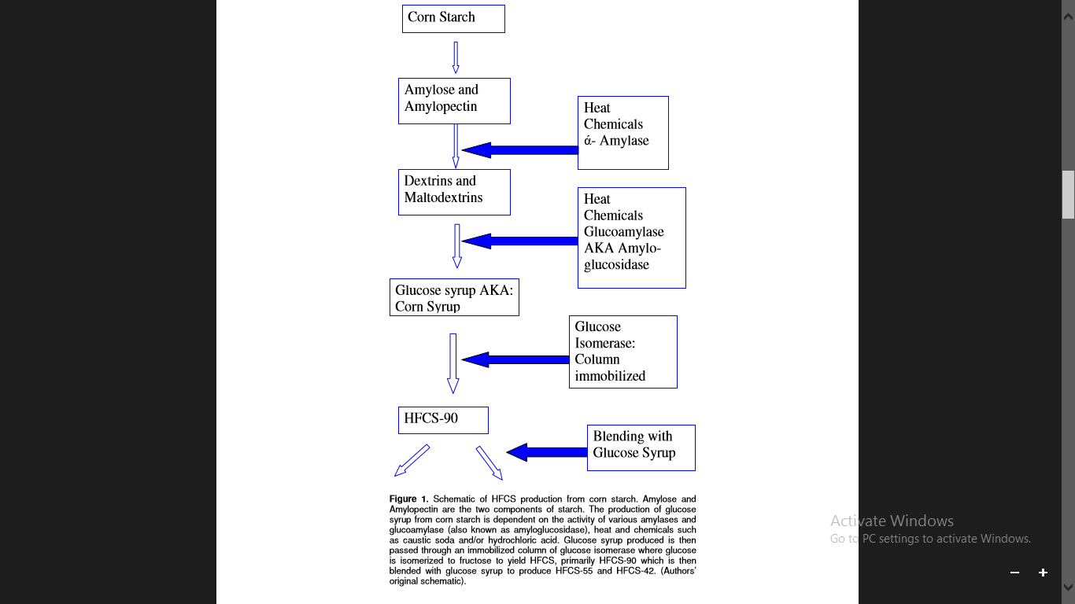
Reference: Parker, K., Salas, M. and Nwosu, V.C. (2010). High fructose corn syrup: Production, uses and public health concerns. Biotechnology and Molecular Biology Review Vol. 5(5)

